
MAHATMA EDUCATION SOCIETY’S
PILLAI COLLEGE OF ARTS, COMMERCE & SCIENCE
(AUTONOMS) NEW PANVEL

PROJECT REPORT WEB PROGRAMMING
ReportGen 2.O – STUDENT REPORT CARD MANAGEMENT SYSTEM

IN PARTIAL FULFILLMENT
BACHELOR OF SCIENCE COMPUTER SCIENCE

SEMESTER II– 2025-26

PROJECT GUIDE
PROFESSOR. SHIVAPRADEEP M.

SUBMITTED BY
KRISHNA KAMLESH SINGH
ROLL NO. 1400
INDEX

CERTIFICATE
INTRODUCTION
NEED OF THE PROJECT
OBJECTIVES OF THE PROJECT
METHODOLOGY
EXPLANATION (SOURCE CODE)
EXPLANATION WITH OUTPUT
SWOT
CONCLUSION

INTRODUCTION

In the modern educational environment, digital systems have become essential for managing academic records efficiently and accurately. Manual report card preparation is time-consuming, prone to human error, and difficult to maintain. To address these challenges, I developed “ReportGen 2.0”, a Student Report Card Management System built using core Web Programming technologies. This project aims to demonstrate how frontend, backend, and database technologies can be integrated to create a functional and user-friendly academic management system.

ReportGen 2.0 is designed with a clean and professional graphical user interface (GUI) to ensure better usability and accessibility. The system allows users to add, view, and delete student academic records through a structured web interface. While developing the project, special attention was given to meeting all the mandatory technical requirements specified for the Web Programming course. The project includes more than three web pages, a structured data entry form, and a dynamic table to display student records. Styling is implemented strictly through an external CSS file, incorporating proper layout techniques, color schemes, hover effects, and box model properties to enhance the overall UI/UX design.
On the functional side, JavaScript has been used to implement form validation (required fields, email validation, and numeric validation), interactive popup messages such as alert and confirm boxes, and a dynamic feature that automatically calculates total marks. The backend is developed using PHP, which processes form submissions and performs database operations. MySQL is used as the database system, containing a table with a primary key to uniquely identify each student record. The system successfully performs core database operations including Insert, View, and Delete, ensuring efficient record management.
Additionally, the main page includes a properly structured footer displaying project and academic details, reinforcing professionalism and ownership. Overall, ReportGen 2.0 demonstrates the practical implementation of web development concepts by combining HTML, CSS, JavaScript, PHP, and MySQL into a complete and functional Student Report Card Management System.

NEED OF THE PROJECT
The development of ReportGen 2.0 – Student Report Card Management System was necessary due to the following reasons:
- Reduction of Manual Work:
Traditional report card preparation involves manual calculations and record maintenance, which is time-consuming and increases the chances of human errors.
- Improved Accuracy in Calculations:
Manual total and grade calculation may lead to mistakes. An automated system ensures accurate and instant computation of marks.
- Efficient Data Management:
Storing records on paper makes retrieval and modification difficult. A database-driven system enables organized storage and easy access to student data.
- Time-Saving Process:
Teachers and administrators can quickly add, view, or delete records without rewriting or recalculating information repeatedly.
- Digital Transformation in Education:
Educational institutions are increasingly shifting toward digital solutions. This project reflects the practical implementation of web technologies in academic management.
- Practical Application of Web Programming Concepts:
The project provides hands-on experience in integrating frontend, backend, and database technologies into a real-world system.

OBJECTIVES OF THE PROJECT
The primary objectives of developing ReportGen 2.0 are:
- To Design a User-Friendly Interface:
Develop a clean and professional GUI using HTML and external CSS with proper layout, colors, hover effects, and structured design.
- To Implement Form-Based Data Entry:
Create a structured form to collect student details with proper labels and validation.
- To Apply Client-Side Validation:
Use JavaScript to validate required fields, email format, numeric input, and provide alert and confirm popups for better user interaction.
- To Automate Calculations:
Implement dynamic calculation of total marks using JavaScript to improve efficiency and accuracy.
- To Integrate Backend Processing:
Use PHP to process form data and interact with the database securely.
- To Perform Database Operations:
Create a MySQL table with a primary key and perform essential operations such as Insert, View, and Delete for effective record management.

METHODOLOGY
The development of ReportGen 2.0 – Student Report Card Management System followed a systematic and structured approach to ensure proper integration of frontend, backend, and database technologies. The methodology involved environment setup, database design, frontend development, backend integration, testing, and deployment using XAMPP. Each stage of development is explained below in detail.

Requirement Analysis
The first step in developing ReportGen 2.0 was analyzing the project requirements specified for the Web Programming course. The system was required to include:
- Minimum three web pages
- At least one form and one table
- External CSS styling
- JavaScript validation and dynamic features
- PHP form processing
- MySQL database with primary key
- Insert, View, and Delete operations
Based on these requirements, the structure and workflow of the project were planned.

System Environment Setup Using XAMPP
To develop and run the project locally, XAMPP was used as the development environment.

What is XAMPP?
XAMPP is a free and open-source cross-platform web server solution stack package. It includes:
- Apache – Web server
- MySQL (MariaDB) – Database server
- PHP – Backend scripting language
- phpMyAdmin – Database management interface

Steps to Install and Configure XAMPP:
- Download XAMPP from the official Apache Friends website.
- Install XAMPP on the system.
- Open the XAMPP Control Panel.
- Start the following services:
  - Apache
  - MySQL
- Ensure both services show green status indicating they are running.
Open browser and type:
http://localhost/
- This confirms the server is working.
Open phpMyAdmin using:
http://localhost/phpmyadmin/
Database Design and Implementation
After setting up XAMPP, the next step was creating the database.

Steps to Create Database:
- Open phpMyAdmin.
- Click on "New" to create a database.
- Name the database: reportcard
- Click "Create".

Creating Table:
A table named students was created with the following structure:
- id (Primary Key, Auto Increment)
- roll_no
- name
- email
- class
- subject1
- subject2
- subject3
- total
Primary key ensures:
- Each record is unique
- No duplicate entries
- Proper identification for delete operation
SQL Query used:
CREATE TABLE students (
id INT AUTO_INCREMENT PRIMARY KEY,
roll_no INT NOT NULL,
name VARCHAR(100) NOT NULL,
email VARCHAR(100) NOT NULL,
class VARCHAR(20) NOT NULL,
subject1 INT NOT NULL,
subject2 INT NOT NULL,
subject3 INT NOT NULL,
total INT NOT NULL
);

Frontend Development (HTML + CSS)
The frontend was designed to provide a clean and professional graphical user interface.

HTML Development
Three main pages were created:
- index.html – Home page
- add_student.html – Form page
- view_students.php – Records display page

HTML was used to:
- Structure content
- Create forms
- Create tables
- Add navigation links
- Add footer with project details
Proper semantic structure and labels were used for better readability.
CSS Implementation (External File Only)
All styling was done using an external file style.css.
CSS was used to:
- Apply professional color theme
- Set fonts
- Implement box model properties (margin, padding, border)
- Add hover effects
- Create layout structure
- Design cards and tables
- Style navigation bar and footer
This ensured:
- Clean UI/UX
- Consistent design
- Separation of structure and styling

Client-Side Scripting (JavaScript)
JavaScript was implemented for interactivity and validation.

1. Form Validation
- Required fields
- Email validation
- Numeric validation
This prevents incorrect data submission.

2. Popup Messages
- alert() for successful submission
- confirm() before deleting record

3. Dynamic Feature
A dynamic calculation feature was implemented:
- When marks are entered
- Total is automatically calculated
- Displayed instantly in total field
This improves user experience and reduces manual calculation errors.

Backend Development (PHP Integration)
PHP was used to connect frontend with database.

Database Connection
File: db_connect.php
- Establishes connection with MySQL using mysqli.
- Ensures communication between system and database.

Form Processing
File: insert.php
- Receives data using $_POST
- Executes INSERT query
- Displays success message
- Redirects to view page

Viewing Records
File: view_students.php
- Executes SELECT query
- Fetches data
- Displays records in HTML table

Delete Operation
File: delete_student.php
- Receives id using $_GET
- Executes DELETE query
- Redirects back to records page

Testing and Debugging
After development, the project was tested thoroughly.
Testing included:
- Checking form validation
- Checking database insertion
- Verifying record display
- Testing delete confirmation
- Checking dynamic total calculation
- Ensuring proper layout and hover effects
- Testing server connection in XAMPP
Errors such as database connection issues and incorrect field names were corrected during testing.

Project Deployment (Localhost Execution)
To run the project:
Copy project folder into:
C:\xampp\htdocs\
- Start Apache and MySQL in XAMPP.
Open browser and type:
http://localhost/1400WEB/

- The system loads successfully.

Overall Development Approach
The methodology followed a step-by-step structured approach:
- Planning and requirement analysis
- Environment setup using XAMPP
- Database creation
- Frontend design
- JavaScript implementation
- PHP backend integration
- Testing and validation
- Final execution
This ensured the successful integration of:
- HTML (Structure)
- CSS (Design)
- JavaScript (Interactivity)
- PHP (Processing)
- MySQL (Data storage)

EXPLANATION OF SOURCE CODE
The project folder named “1400WEB” is stored inside the htdocs directory of XAMPP. This allows the project to run on the local Apache server using http://localhost/1400WEB/.
The folder contains the following files:
- index.html
- add_student.html
- view_students.php
- insert.php
- delete_student.php
- db_connect.php
- style.css
- script.js
Each file has a specific role in the functioning of ReportGen 2.0.

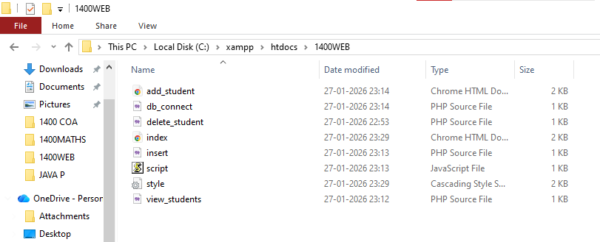
Setting up of FOLDER-FILE

index.html – Home Page

This is the main landing page of the project.

Purpose:

Displays project title

Navigation links (Add Student, View Records)

Hero section

Feature cards

Footer with project details

Requirements Implemented Here:

3+ HTML Pages
This is the first HTML page.

External CSS
<link rel="stylesheet" href="style.css">

Hover Effects
Navbar links and buttons use hover styling from style.css.

Box Model
Cards and layout use padding, margin, border-radius, and box-shadow.

Footer with Your Name

<footer class="footer">

<p>© 2025 Krishna K Singh. All rights reserved.</p>

<p>PCACS BSC FYCS | SEM 2 WEB PROGRAMMING | 1400 KRISHNA K SINGH</p>

</footer>



add_student.html – Student Entry Page

This page contains the data entry form.

Purpose:

Collect student details

Send data to PHP backend

Requirements Implemented Here:

One Form
<form action="insert.php" method="POST" onsubmit="return validateForm()">

JavaScript Validation
Connected using:
<script src="script.js"></script>

Required, Email, Number Validation

<input type="email" required>
<input type="number" required>

Dynamic Calculation

onkeyup="calculateTotal()"
Automatically calculates total marks.

External CSS
Uses style.css for layout and styling.

Box Model
Form container uses padding, margin, shadow effects.

view_students.php – Display Records Page

This page retrieves and displays student data from the database.

Purpose:

Fetch records from MySQL

Display them in table format

Provide delete option

Requirements Implemented Here:

One Table
<table>
Displays student records.

View Operation
SELECT * FROM students

Delete Option
<a href="delete_student.php?id=...">

Confirm Popup
onclick="return confirm('Are you sure?')"

External CSS
Table styled using style.css.

insert.php – Insert Operation

Purpose:

Process form submission

Insert data into database

Requirements Implemented:

PHP Form Processing
$_POST['name']

Insert Operation
INSERT INTO students (...)

Alert Popup
echo "<script>alert('Student Record Added Successfully');</script>";

delete_student.php – Delete Operation

Purpose:

Delete student record using ID

Delete Operation
DELETE FROM students WHERE id=$id

Primary Key Usage
Deletion is done using id which is the primary key.

db_connect.php – Database Connection

Purpose:

Connect PHP with MySQL

$conn = new mysqli("localhost", "root", "", "reportcard");

This file ensures backend communication with the database.

style.css – External Styling File

Purpose:

Control full design and layout

Requirements Implemented:

External CSS Only

Colors and Fonts
background-color: #f8fafc;
font-family: 'Segoe UI';

Hover Effects
button:hover { }
.navbar a:hover { }
.card:hover { }

Box Model
Padding
Margin
Border-radius
box-shadow

This file ensures visual consistency and professional UI.

script.js – JavaScript File

Purpose:

Add validation

Add dynamic functionality

Add popup interaction

Requirements Implemented:

JavaScript Validation
function validateForm()

Alert Popup
alert("Form submitted successfully!");

Confirm Popup
Used in delete action.

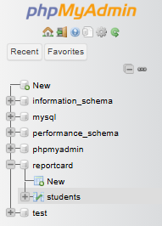
Dynamic Calculation
function calculateTotal()
Automatically updates total marks.

MySQL Database Explanation

Database Name: reportcard
Table Name: students

id INT AUTO_INCREMENT PRIMARY KEY

Primary Key
Ensures unique identification.

Insert
From insert.php

View
From view_students.php

Delete
From delete_student.php

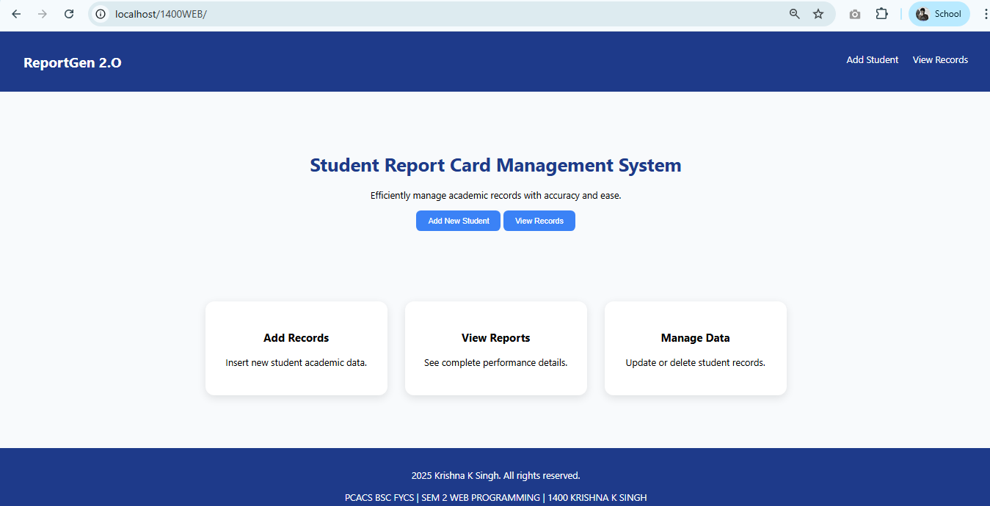
SAMPLE OUTPUT SCREENS
Main Web PAge

Navigation-Bar
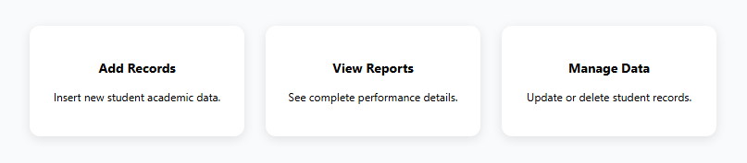
Hover affected CSS style
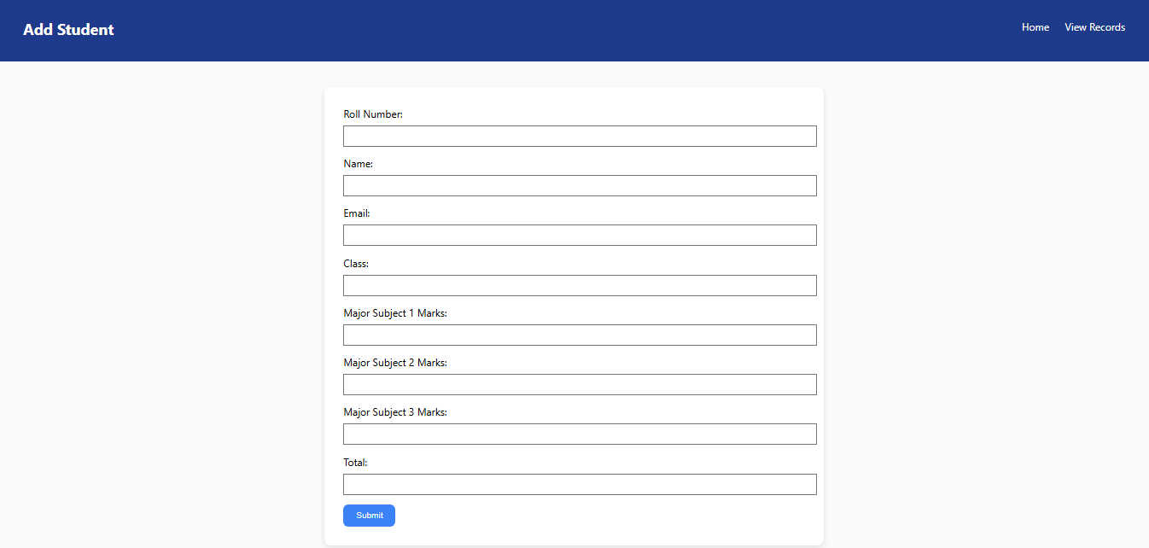
When person clicks on Add Student Navigation
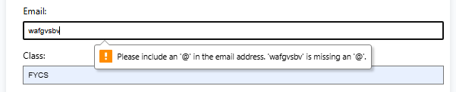
Email Validation
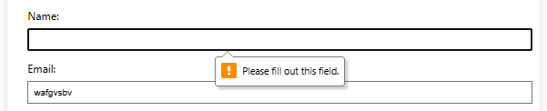
Required Validation

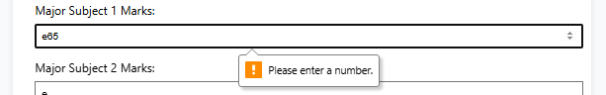
Number Validation
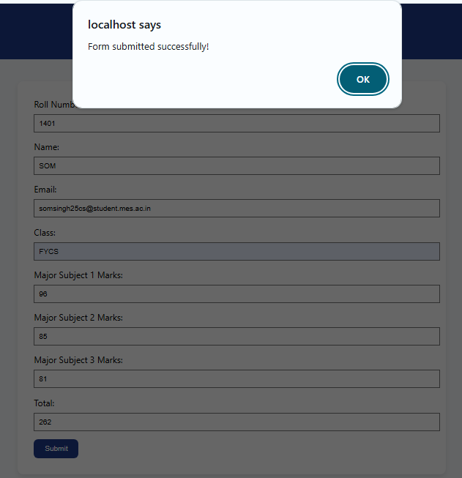
Pop-up when we submit form

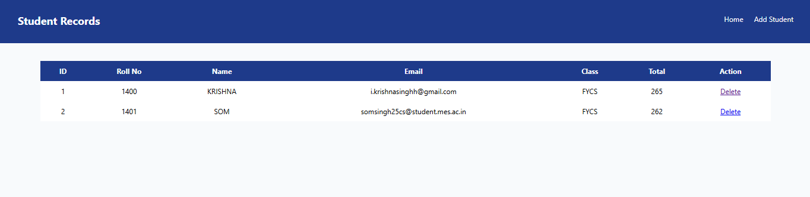
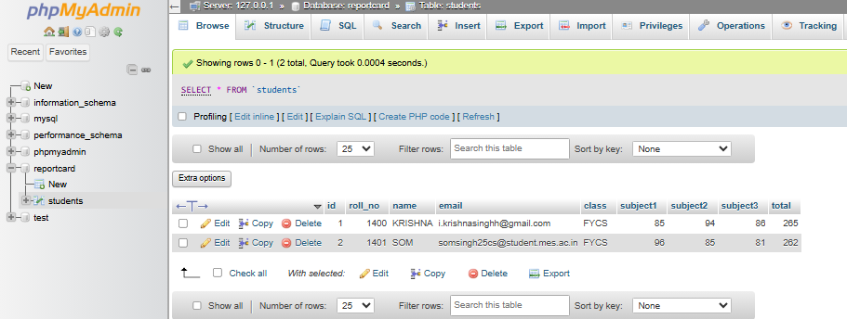
Navigation on “ADD STUDENT” Web page- When we Click on View Record
When Clicked to View Record- Data Submitted to Database will be shown
Saved Database

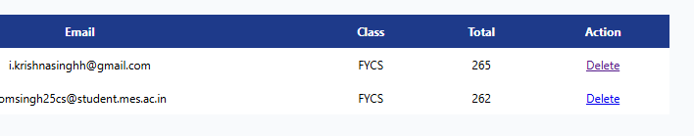
In “View Records” if we click on “Delete Action”
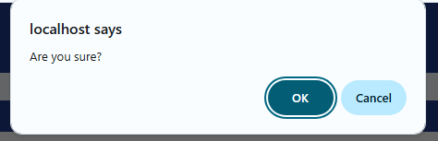
Pop-up will appear Click ok
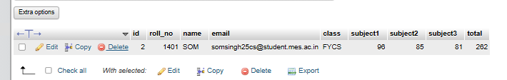
The Student is Deleted from Webpage
Also deleted from Database

SWOT ANALYSIS
Strengths
ReportGen 2.0 is a fully functional web-based system that integrates HTML, CSS, JavaScript, PHP, and MySQL into one complete application. The project successfully meets all academic requirements including multiple web pages, form handling, database connectivity, and CRUD operations (Insert, View, Delete). The use of external CSS ensures a clean and professional user interface with proper layout, hover effects, and box model implementation. JavaScript validation and dynamic total calculation improve accuracy and user experience. The use of a primary key in the database ensures data integrity and uniqueness of records. The system runs smoothly on XAMPP, demonstrating proper understanding of local server configuration and backend integration.
Weaknesses
The project runs on a local server environment and is not deployed online, limiting real-world accessibility. Security features such as advanced input sanitization, prepared statements, and authentication mechanisms are basic and can be improved. The system currently supports limited subjects and operations, as it does not include update functionality or advanced search filters. The user interface, while clean, can be further enhanced with responsive design techniques for better mobile compatibility.
Opportunities
The system can be expanded into a complete school management system by adding features such as login authentication for teachers and administrators, update/edit functionality, grade calculation logic, and downloadable report cards in PDF format. It can also be deployed on a live server to allow real-time online access. Integration with advanced technologies such as AJAX for asynchronous data loading or frameworks like Bootstrap for responsive design can further improve performance and usability. Cloud database integration can make the system scalable for larger institutions.
Threats
Potential security risks such as SQL injection, unauthorized access, or data breaches may affect system reliability if not handled properly. Server misconfiguration in XAMPP or improper database management can lead to data loss. As technology evolves rapidly, outdated web practices may reduce system efficiency if not regularly updated. Additionally, dependency on local server setup may create compatibility issues across different systems if not configured correctly.

CONCLUSION
The development of ReportGen 2.0 – Student Report Card Management System successfully demonstrates the practical implementation of core Web Programming concepts in a real-world academic scenario. The project effectively integrates frontend technologies such as HTML and CSS with client-side scripting using JavaScript, and backend processing using PHP connected to a MySQL database. This integration clearly shows how different web technologies work together to build a complete, functional, and database-driven application.
The system addresses the limitations of manual report card preparation by automating student record management, total marks calculation, and data storage. Through structured form submission, dynamic calculation of total marks, proper validation techniques, and database connectivity, the application ensures accuracy, efficiency, and organized record handling. The implementation of Insert, View, and Delete operations using a primary key strengthens data integrity and demonstrates a clear understanding of CRUD functionality.
The project also fulfills all the academic requirements specified for the Web Programming course. It includes multiple web pages, a structured form, a dynamic data table, external CSS styling with hover effects and box model properties, JavaScript validation with alert and confirm popups, PHP-based form processing, and a properly designed MySQL database. The successful configuration and use of XAMPP for local server deployment further reflects practical knowledge of server-side environment setup and execution.
During the development process, this project enhanced understanding of client-server architecture, database connectivity, debugging techniques, and structured coding practices. It provided hands-on experience in integrating different technologies into a single system, strengthening problem-solving skills and technical confidence.
In conclusion, ReportGen 2.0 is not only an academic submission but also a foundational step toward building larger web-based management systems. The project demonstrates how web programming technologies can be applied to create efficient, accurate, and user-friendly solutions for educational institutions, while also laying the groundwork for future enhancements and scalability.

1400. KRISHNA K SINGH
FY B.Sc. Computer Science – Semester II

